1. Let’s talk about **two-way binding**.
2. **$event:** Contains the data about event. It would simply be data emitted from the event.
3. 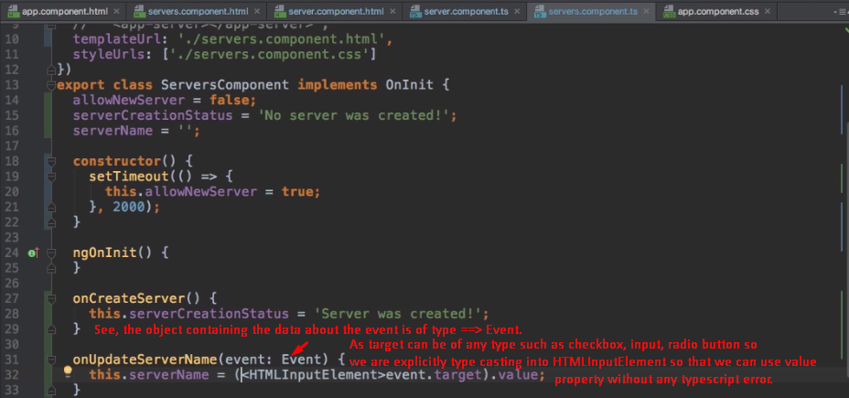  
   **NOTE**: (<HTMLInputElement>event.target)🡸 See the parameter type is event: Event and this object and contain reference to any kind of tag on which event has occurred. So, when you try event.target, how would typescript would be able to show you specific properties list from intelligence as event.target can contain reference to any kind of DOM object.
4. 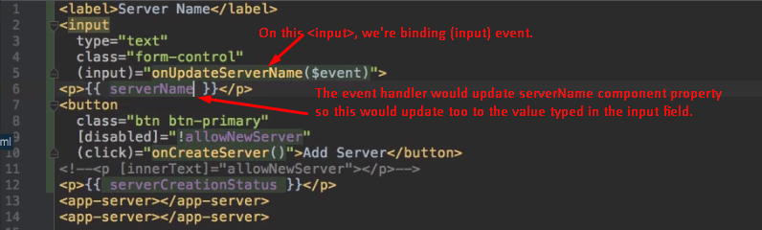
5. 